Luke Kaschmitter
MIS 2040
December 12th, 2023
Can the Profitability of Insider Trades be Predicted?
Objectives
This analysis attempts to answer the question of whether the profitability of legal insider trades can be predicted using publicly available information. In other words, could a layperson reliably use certain indicators to match predicted profitable insider trades and potentially net a profit themselves? In addition to the main question posed above, this analysis also attempts to answer two tangential questions. First, do insider trades follow a daily trend? Second, which S&P 500 sectors have the most frequent and profitable insider trading activity?
Methods
The insider trading database used in this analysis contained insider trading data from January 1st, 2023, to November 30th, 2023. The database combines daily insider trading transaction data from OpenInsider.com, weekly consumer sentiment survey data from the American Association of Individual Investors (AAII), and stock ticker information from Yahoo Finance.
OpenInsider.com is a free, public website that compiles insider data obtained from the SEC EDGAR database, where insiders are required to file transaction reports. This data includes filing date (FDate), trade date (TDate), ticker, company, trade type, stock price (Price), share quantity (Qty), shares currently owned (Owned), percentage change in shares owned (OwnChange), trade value (Value), and the time difference between TDate and FDate (FilingTime).
The consumer sentiment survey data is released weekly by the AAII and asks individual investors whether they believe the direction of the stock market over the next six months will be up (bullish), no change (neutral), or down (bearish). Database variables pulled from this survey include bullish, neutral, bearish, bullish 8-week moving average, and bull-bear spread and are expressed as percentages.
The yahoo finance data is appended using the yfinance API, a non-affiliated API created by Ran Aroussi. The database variables included from this source are the incorporated state (State), sector, industry, and market capitalization for each ticker and the S&P 500 close for each TDate. This API was also used to calculate the two main dependent variables, percentage profit and dollar profit. Both profit variables were calculated for purchase transactions by taking the difference between the value at the TDate and the value at the TDate plus 180 days or the November 30th, 2023 (whichever was earliest). Both profit variables were calculated for sale transactions by taking the difference between the TDate minus 180 days or January 1st, 2023 (whichever was latest) and the TDate. 180 days was chosen as it is the minimum holding period allowed for insiders between the purchase and sale of a security under Section 16(b) of the Securities and Exchange Act.
The effect of database variables on the dollar profit or percentage profit of an insider trade was calculated through multiple linear regression models using the ordinary least squares method. These regression models used recursive feature elimination (RFE) to maximize the R-squared regression value. Along with the numerical variables in the database, this regression included independent dummy variables for sector and state.
The database included 52,771 total transactions composed of 13,640 purchases and 39,131 sales. 16,177 unique insiders conducted these trades.
Results
As seen in Figure 1, no independent individual numerical variable was significantly correlated to percentage profit or dollar profit. Additionally, the relationships between any one numerical variable and another did not exceed |0.27|, except for those that exhibited collinearity. The percentage profit RFE regression yielded a maximum R-squared value of 0.00219 with 81 features (variables included). The percentage profit residuals graph reflects this low R-squared value, as seen in Figure 2. The dollar profit RFE regression yielded a maximum R-squared value of 0.02284 with 82 features. The dollar profit residuals graph reflects this low R-squared value, as seen in Figure 3.
As shown in Figure 4, sales appeared to occur primarily at the beginning of each month with another spike around the 7th and around the 17th of each month. Purchases were more metered, with small spikes on the 3rd and 15th of each month. Additionally, sales overwhelmingly occurred at the beginning of 2023.
As shown in Figure 5, consumer cyclical was the sector with the highest median profit, while real estate had the highest median dollar profit. As shown in Figure 6 , the technology sector amassed the greatest number of sale transactions while the financial services sector amassed the greatest number of purchase transactions over the period studied.
Conclusions
Unfortunately, no independent variable included in the study could reliably explain the variability of the profitability of insider trades. Thus, none of the variables used as independent variables in the regressions in this study should be used to predict the profitability of insider trades. Additionally, the consumer cyclical and real estate sectors were the most profitable sectors by percentage and dollar profit, respectively. Finally, insiders overwhelmingly sold at the beginning of 2023, with the majority of those sales occurring in the technology sector.
This study certainly had a some shortcomings. The first was an element of multi-collinearity between some independent variables in the regression calculations, with the consumer sentiment survey data variables of particular note. Additionally, the period studied only included 11 months of data. Finally, the profitability calculation is relatively vague and generalized. However, only 0.8% of insiders in the database purchased a security and subsequently sold that security in the period studied, meaning using these “round-trip” trades for profitability values would have yielded a smaller database than desired for model accuracy.
Future analysis along the guidelines of this study could use a more reliable insider trade transaction database, such as the paid database compiled by Thomas Reuters. Future analysis should also use a larger timeframe to account for potential seasonal variation. Finally, future researchers could account for recent insider trading regulation changes, such as the Rule 10b5-1 amendments to the Securities Exchange Act adopted in December of 2022.

Appendix
Figure 1: Regression Variable Correlation Heatmap
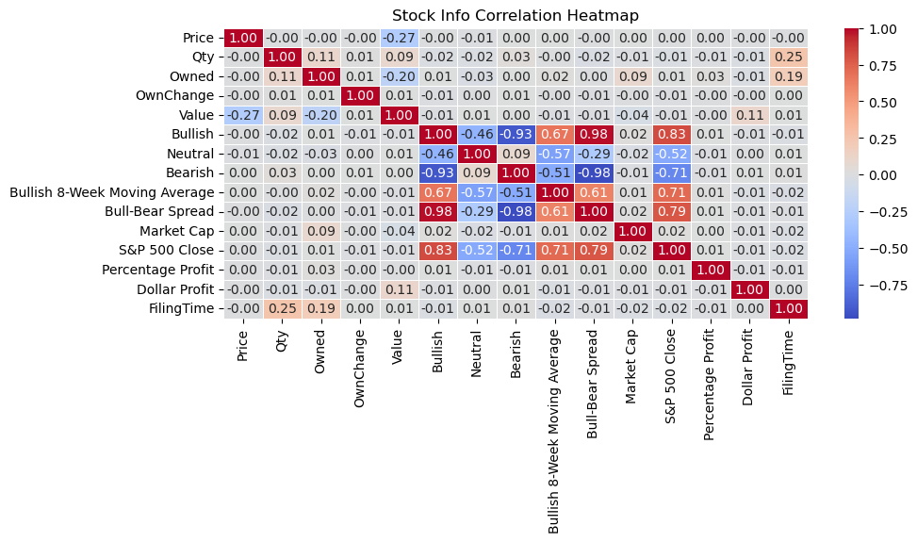
Figure 1. This figure details the correlation coefficients between notable numerical variables in the insider trading database. The bullish, neutral, bearish, bullish 8-week moving average, and bull-bear spread are all collinear consumer sentiment variables, and the relationships are not significant in this analysis. Additionally, those consumer sentiment variables are related to the S&P 500 close, another relationship not significant to this analysis.
Figure 2: Percentage Profit Residual Analysis
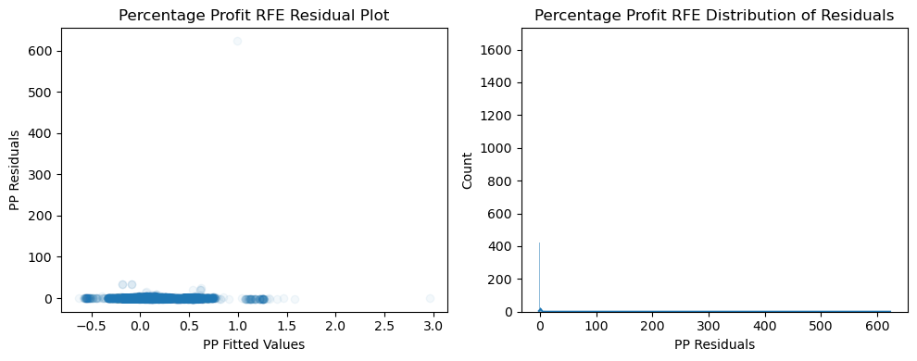
Figure 2. This figure details the residuals (PP Residuals) and fitted values (PP Fitted Values) for the percentage profit regression analysis in the left chart. The right chart shows the distribution of residuals from the percentage profit regression.
Figure 3: Dollar Profit Residual Analysis
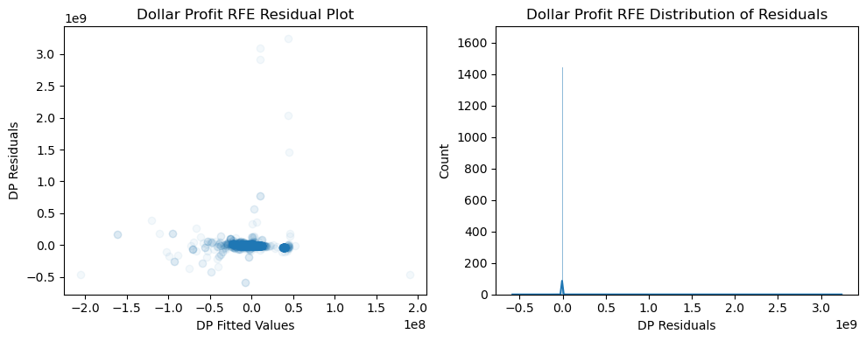
Figure 3. This figure details the residuals (DP Residuals) and fitted values (DP Fitted Values) for the dollar profit regression analysis in the left chart. The right chart shows the distribution of residuals from the dollar profit regression.
Figure 4: Insider Trades over Time
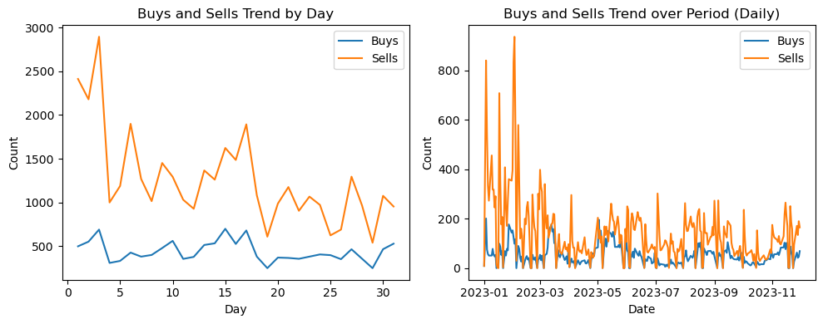
Figure 4. The left chart in this figure shows the total purchases (buys) and sales (sells) made on each numbered day of the month over the study period by insiders. The right chart in this figure shows the total purchases (buys) and sales (sells) made daily over the study period by insiders.
Figure 5: Most Profitable Insider Trades by Sector
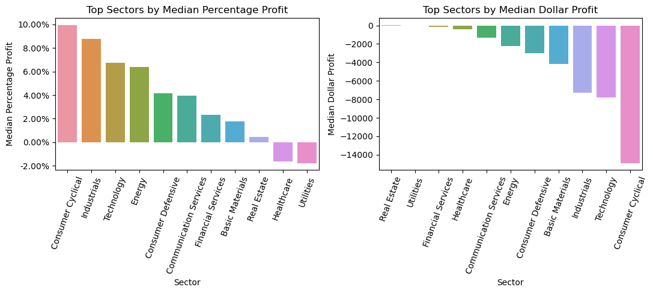
Figure 5. The left chart in this figure shows the median percentage profits for insiders in each of the 11 sectors in the S&P 500. The right chart in this figure shows the median dollar profit for insiders in each of the 11 sectors.
Figure 6: Most Frequent Insider Trades by Sector
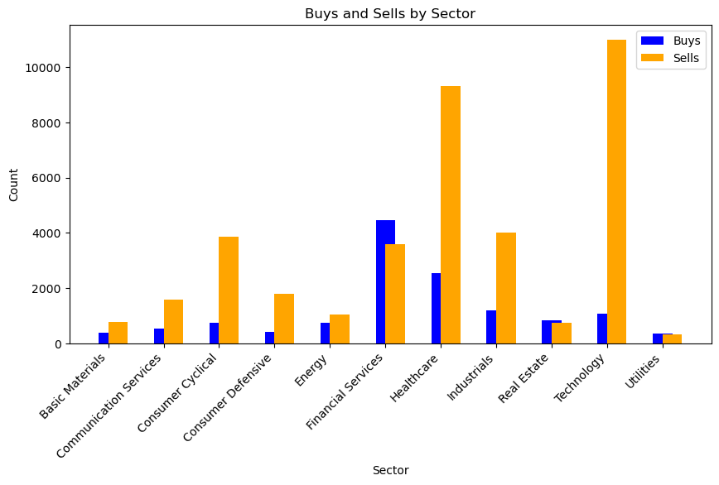
Figure 6. This figure shows the total purchases (buys) and sales (sells) made by insiders in each of the 11 sectors in the S&P 500 over the study period.

